Makungu Siweya
ST10453070
PROG6212 PART 1

Section A:
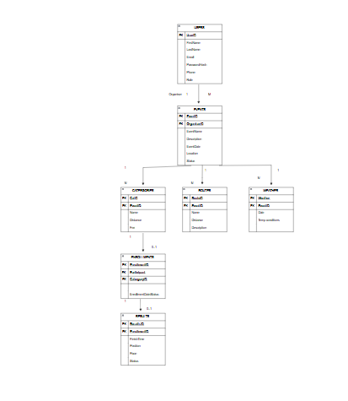

Section B:

HTTP Method | Route | Description | Role required | Request body | Expected response
POST | /api/auth/register | Registers a new RaceDay user account. | None | {firstName, lastName, email, password, role} | 201 Created – user registered. 400 Bad Request- invalid details.
POST | /api/auth/login | Authenticates a user and provides access to the system. | None | {email, password} | 200 OK – login successful.401 Unauthorized- incorrect details.
GET | /api/events | Returns details a list of available | None | None | 200 Ok list of events. 400 Not Found – event not found.
GET | /api/events/ {id} | Returns details for one specific RaceDay event. | None | None | 200 Ok list of events. 400 Not Found – event not found.
POST | /api/events | Creates a new RaceDay event. | Organiser | {eventName, Description, eventDate, location} | 201 Created- event created. 400 Bad Request – invalid data.
POST | /api/enrollments | Registers a participant for an event category. | Participant | { categoryID } | 201 Created- participant enrolled. 409 Conflict already enrolled
GET | /api/enrollments/me | Shows the events and categories the loggin-in participant has entered. | Participant | None | 200 Ok enrolment list. 401 Unauthorized – not logged in.
GET | /api/events/{id}/results | Displays results for participants in a specific event. | None | None | 200 Ok event results. 404 Not Found – results not found.
POST | /api/results | Records a participants race result. | Organiser | { enrolmentID, finishTime, position, pace} | 201 Created result recorded. 400 Bad Request – invalid result.
GET | /api/users/me | Returns the profile information of the logged in user | Logged in user | None | 200 Ok user profile. 401 Unauthorized – not logged in.
PUT | /api/users/me | Updates the logged in user’s profile information. | Logged in user | { firstName, lastName, phone} | 200 Ok profilr updated. 400 Bad Request – invalid data.

